Promoting your free or paid event

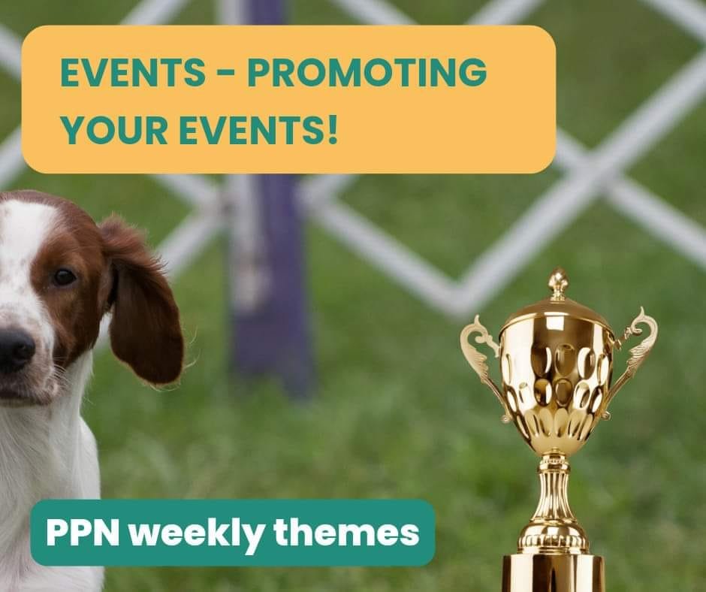
Examples of events:

- Local community events
- Dog show
- Village fete
- Vet Q and A
- Networking
- Rescue talk
- Vet talk
- Co-working
- Online dog show
So, you've got your potential event set up so now down to the important stuff.
1. Facebook event
Firstly, I would create an event on your Facebook Page - now you want people to be genuinely interested so we recommend linking official tickets to order at:
Eventbrite (there's a free option for free events) Or other event booking platforms. Of course, if it's a paid or free event, you may have the option to purchase on your website.
2. Your Facebook group
I'd recommend sharing your event into your own group and perhaps raising awareness doing a live feed. You can create interest and taster snippets running up to the event.
3. Other groups
With admin permission you can share on other groups, for me a good group is Cheltenham Noticeboard.
4. Friends support
Spread the word to your friends and family, encourage them to share the event.
5. Magazine feature
Could you promote in a magazine, have a nice feature?
6. Message clients/other pet pros/businesses
Get in contact with previous and past clients - if you have Mailchimp you can message at the same time. It could also be worth messaging other Pet Pros and even some kind of collaboration. Remember community is the key so even getting other local businesses involved mat really help!
7. Venue support
Could the venue share on their page or encourage their regulars to join?
8. Poster/flyers
With permission pop a poster on community boards. Also, you could have a flyer at your vets.
9. Facebook ads
I always recommend with Facebook ads looking for professional help. It's so important to get the audience right and not just simply boost posts.
10. Sponsorship
Some companies may welcome you as a sponsor. You could use this to promote your events.

